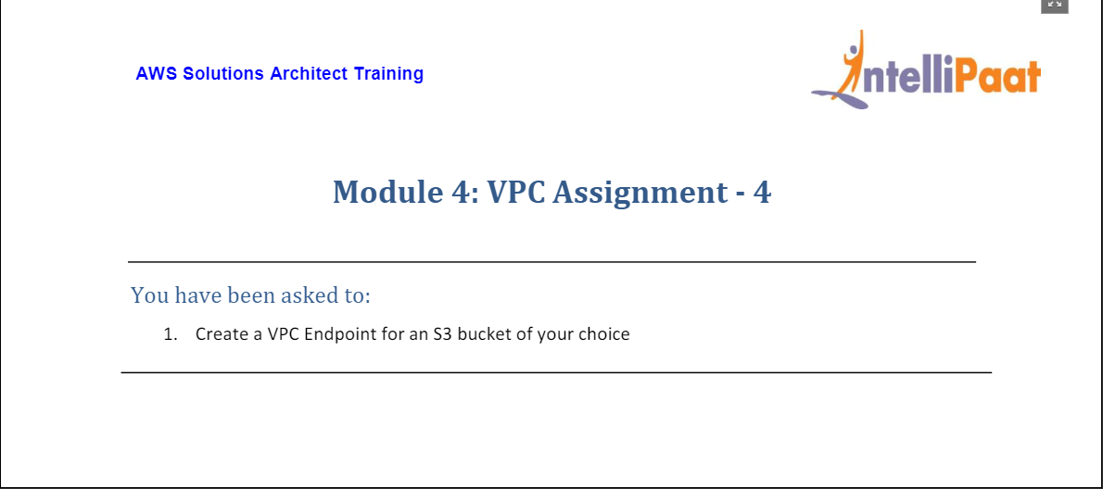

* Created a VPC Endpoint for an S3 bucket.

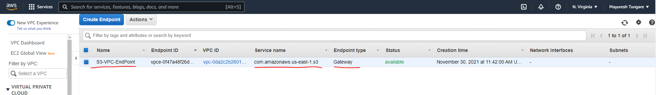

* We observe that route table is also now updated with VPC endpoint that we created.

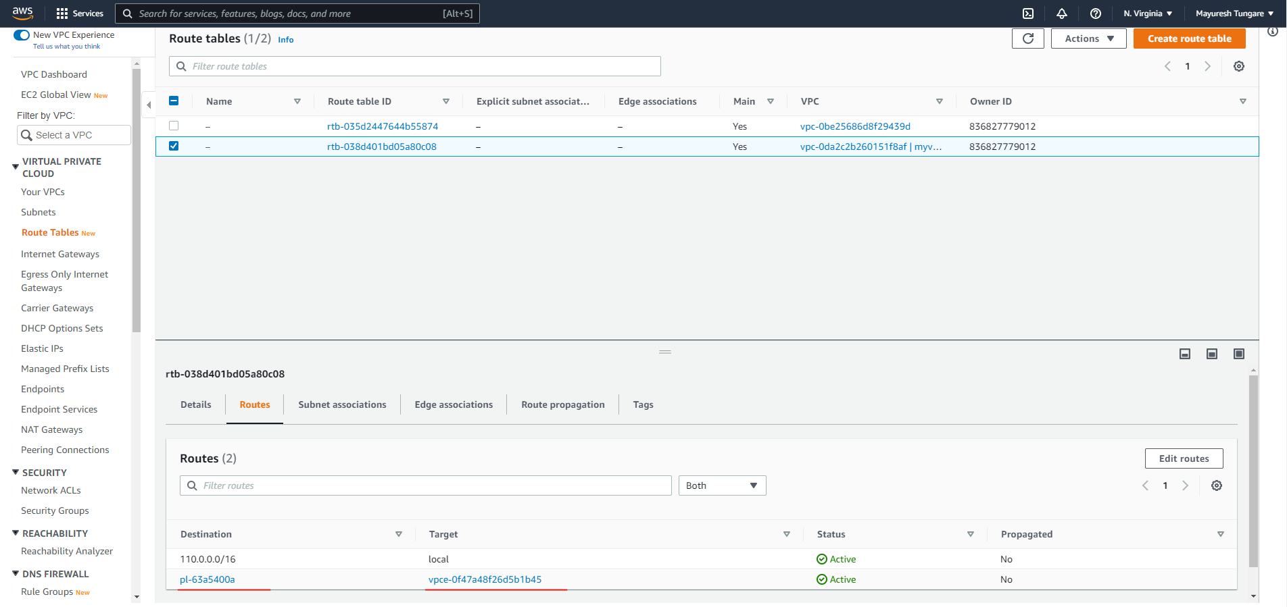

* We now create a S3 bucket (mod4ass4vpce)

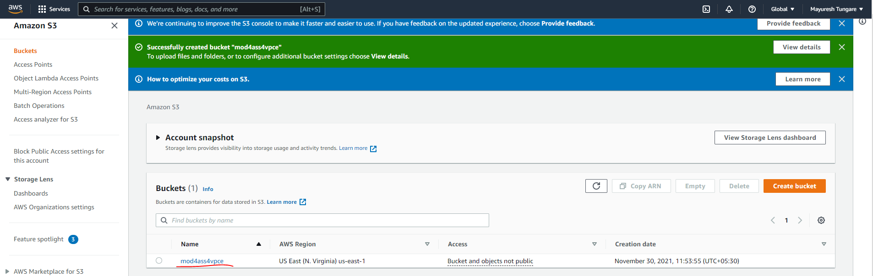

* We now update bucket policy for S3 to allow connection from only the VPC Endpoint

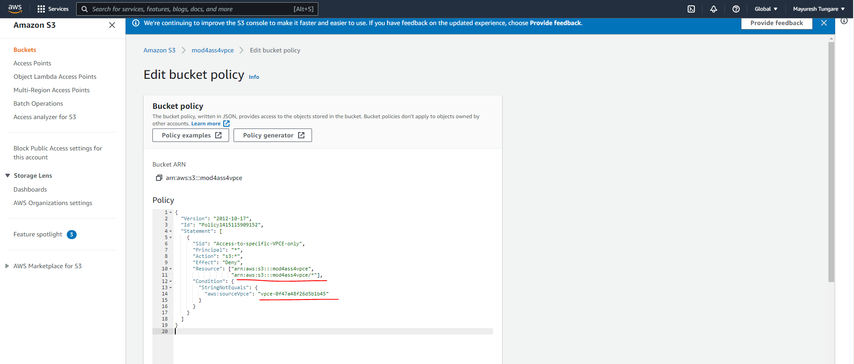

The assignment is now complete.